Assignment 8.2

Name : Y Vasudev

Batch : DA with R , Excel and Tableau

library(RcmdrPlugin.IPSUR)

data(RcmdrTestDrive)

Perform the below operations:

1. Compute the measures of central tendency for salary and reduction which variable has highest center?

2. Which measure of center is more appropriate for before and after?

Boxplot of before . the circles are separated from the box and departures from symmetry. the distribution is highly skewed with extreme values abd shall fall back to median which is resistant to extremes.

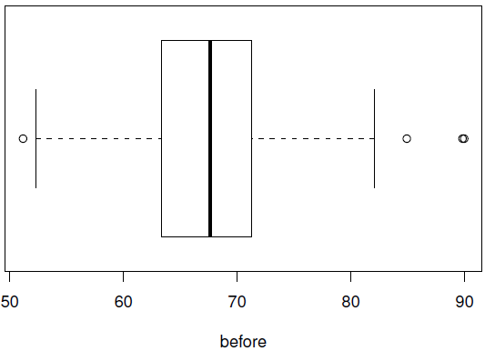

Boxplot of after . the after variable is left skewed .

Median is a good choice of variable

